MATH 8 UNIT 1

SYSTEMS OF EQUATIONS AND INTRODUCTION TO ANGLES

NAME: ______________________________________

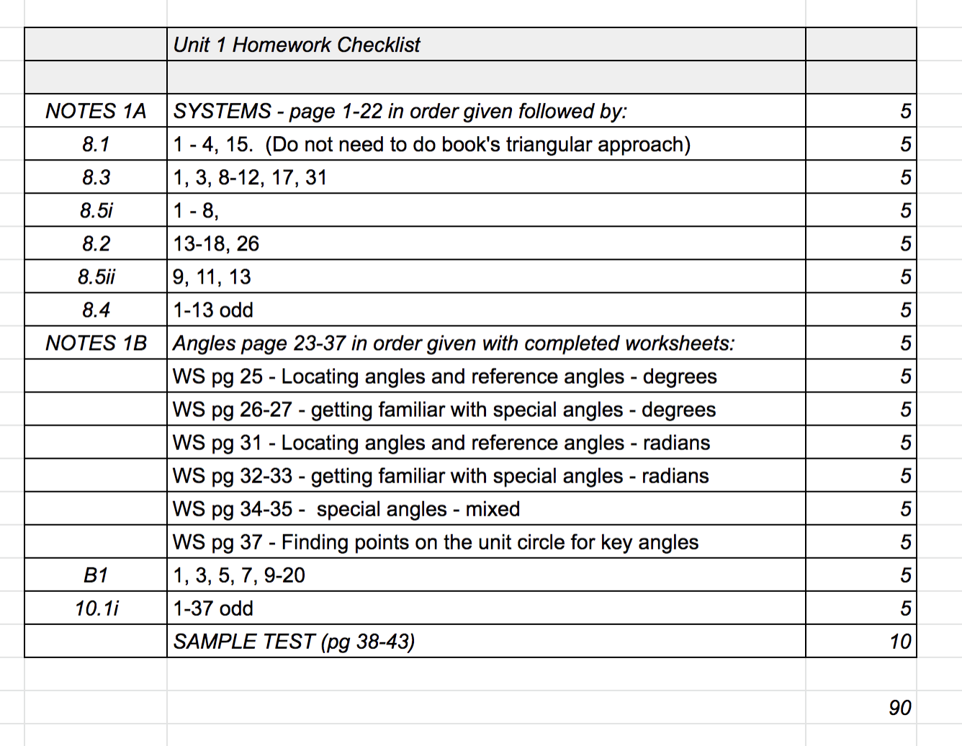

Unit 1 part A– Matrices, Systems of Equations

8.1 Linear Systems of Equations *(note: lighter coverage than book)*

Warm up: Solve the following 2X2 Linear Systems (2 equations with 2 unknowns):





Case: ___________________ _____________________ __________________

Linear System in two variables: ____________________________________________________

Solution: ________________________________________________________________

Methods(thus far): 1)_____________________2)_____________________3)_____________________

Linear Systems in 3 Variables

3 variables => 3 dimensions

Solutions are _______________________

Graph of a linear equation in 3 variables is a ___________________

Many cases for solutions to a linear system in three variables:

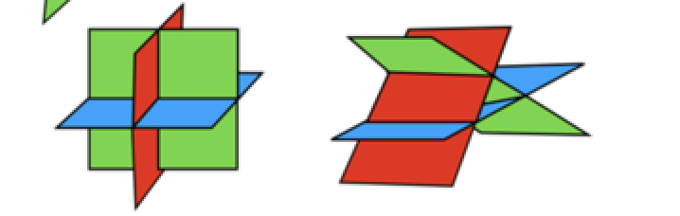….

____________ _____________ _______________ _______________ ______________

Methods (thus far) 1)________________ 2)______________________

Example :



(note, book does differently, eliminate x, upper triangular)

Special case 1 example:



Special case 2 example:



Writing the solution to a dependent system.

8.3 Introduction to Matrices – Matrix Arithmetic

Matrix:

Size:

Square matrix:

Subscript Notation: Let aij be the entry of matrix A in row i and column j. If A is an mxn matrix, then

 So for matrix A=, 

Matrix Operations

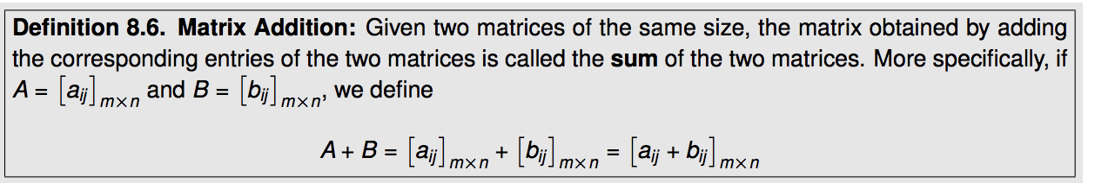

If find

1) A+C 2) A+B

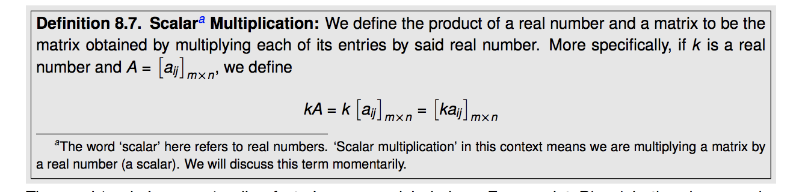

3) Compute 3A 4) Compute 4C-A

Matrix Multiplication

Special case: Row matrix times column matrix. Examples:

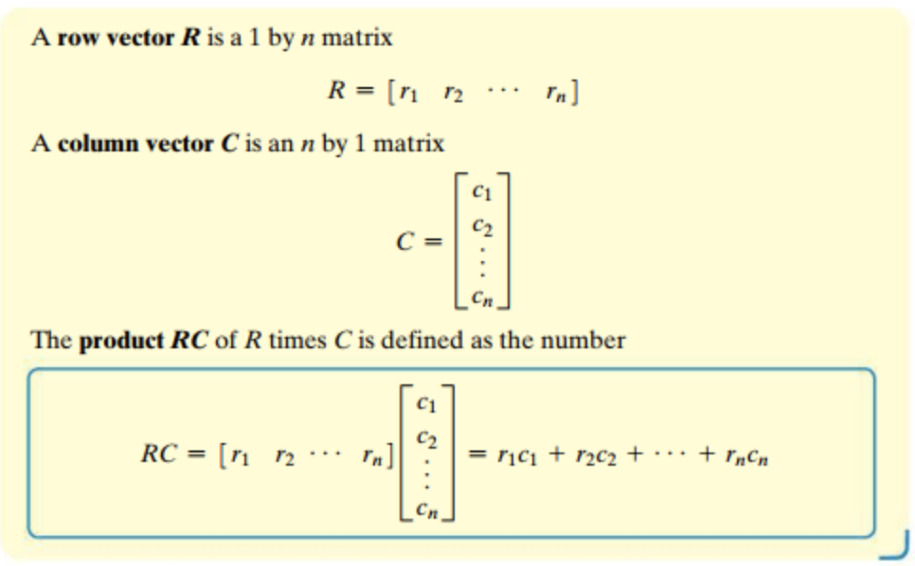

General matrix multiplication:

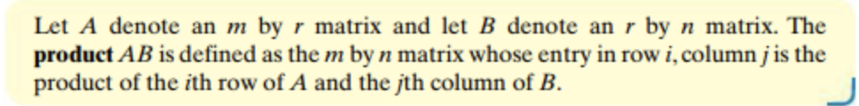

Ex:

= 

Ex:  Find 1) AC

2) CA

3) A2

Notice: Matrix multiplication is NOT __________________________

Identity Matrix

 Find: 

8.2 Gaussian Elimination and Gauss-Jordan

A way of solving linear systems of equations using matrices to help organize operations.

A system of linear equations can be represented by a matrix called an augmented matrix.

EX: System:  => Augmented Matrix

EX: Augmented Matrix:  => System

EX: Write the following Augmented matrices as a system, then solve the system:

Row Echelon Form: 

Reduced Row Echelon Form 

Observation: If an augmented matrix is in Row Echelon Form, or Reduced Row Echelon form, it is easy to solve the corresponding system.

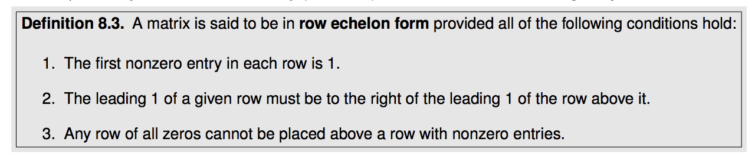

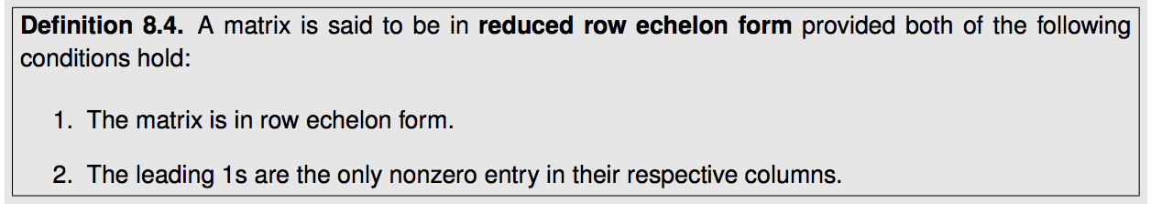

EX: Are the following in Row Echelon Form, Reduced Row Echelon Form or Neither?

   

Gaussian/Gauss Jordan Methods

Goal of Gaussian Elimination: Given a linear system of equations, perform a series of “allowed row operations” to an augmented matrix to find a matrix in row echelon form representing an equivalent linear system. Then solve the simpler system. (If the process is continued to obtain reduced row echelon form, this is called Gauss-Jordan method.)

Illustration of the method:

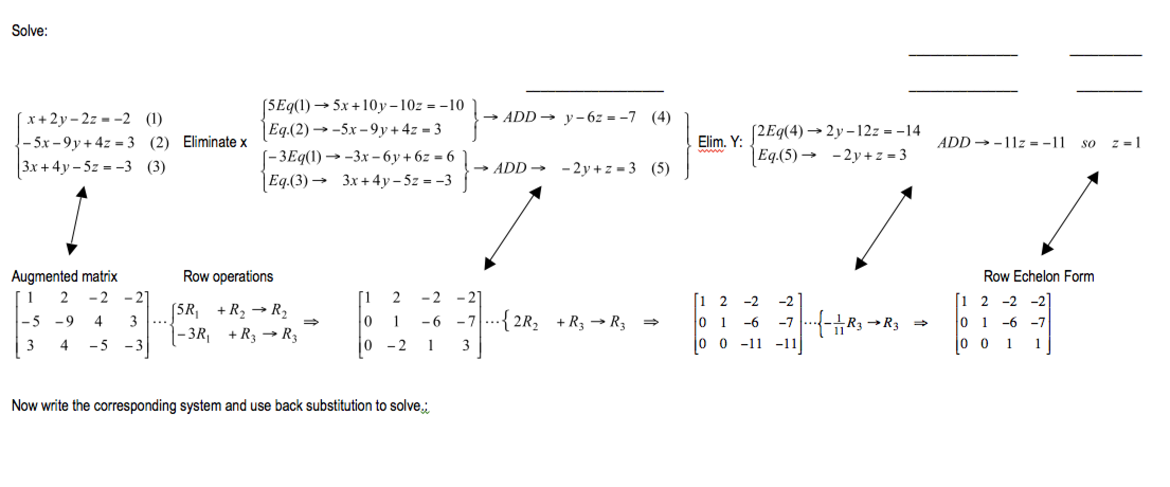

Elementary Row Operations:

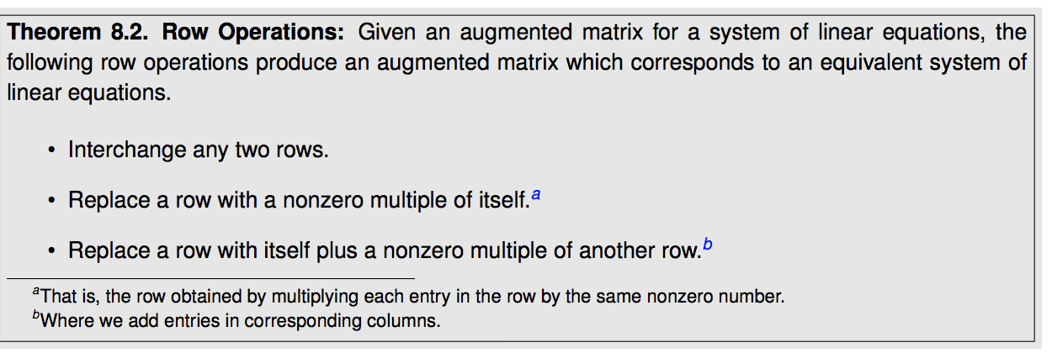

EX: Practicing Random Row Operations:

 



The key to Gaussian elimination is to learn how to choose row operations that will yield row echelon form.

EX: Solve: 

------------🡪

EX: Solve: 

First write the augmented matrix, then obtain a 1 in position , and then use that 1 to get zeros below it.

EX: 4X4 Gaussian Elimination / Gauss Jordan Example

Solve: 

  

  



This is row echelon form. If using Gaussian elimination you can stop your row operations here, write the corresponding system, and use back substitution to find the solution. If using Gauss-Jordan then continue with row operations until reduced row echelon form is achieved.

Continuing, getting zeros above the leading ones…

   

From here we can see the solution, x=1, y=-1, z=1, w=2, that is (1, -1, 1, 2).

There are many other sequences of row operations that are acceptable, but they must achieve the same solution in the end. With practice, you will be able to combine more operations into each step.

Gaussian Elimination: Dependent and Inconsistent Case Examples

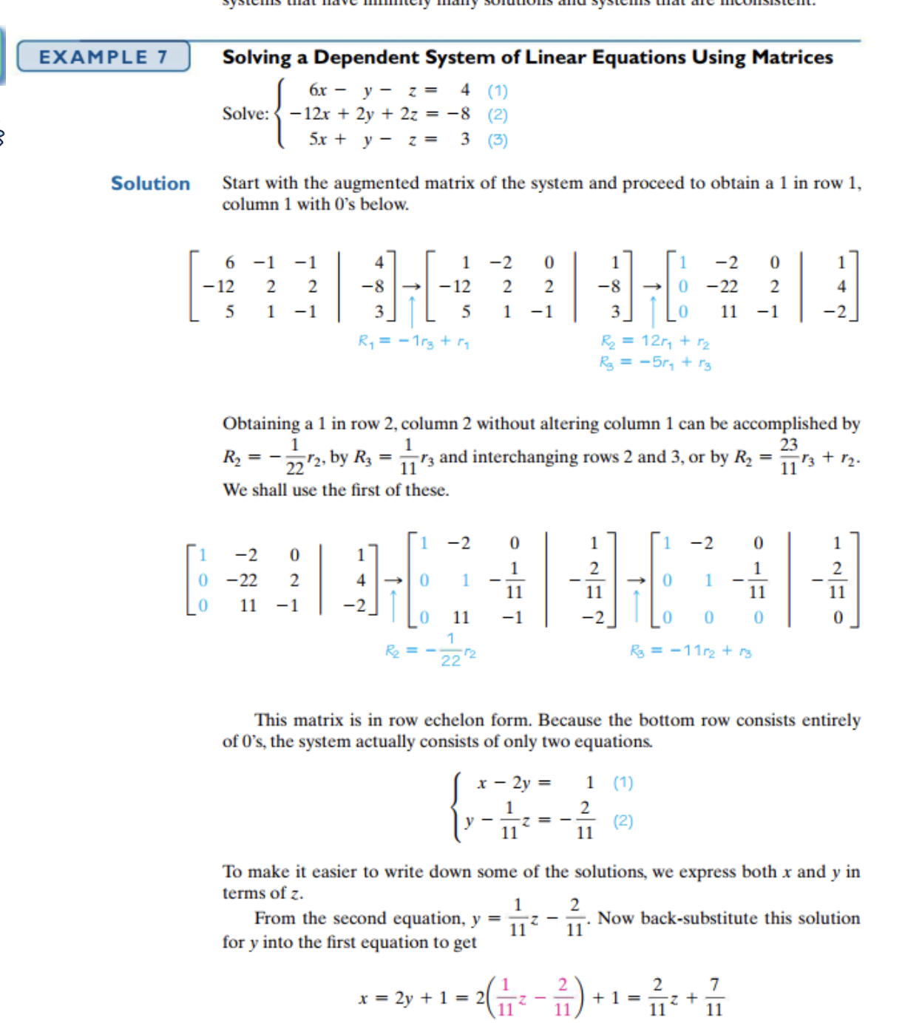

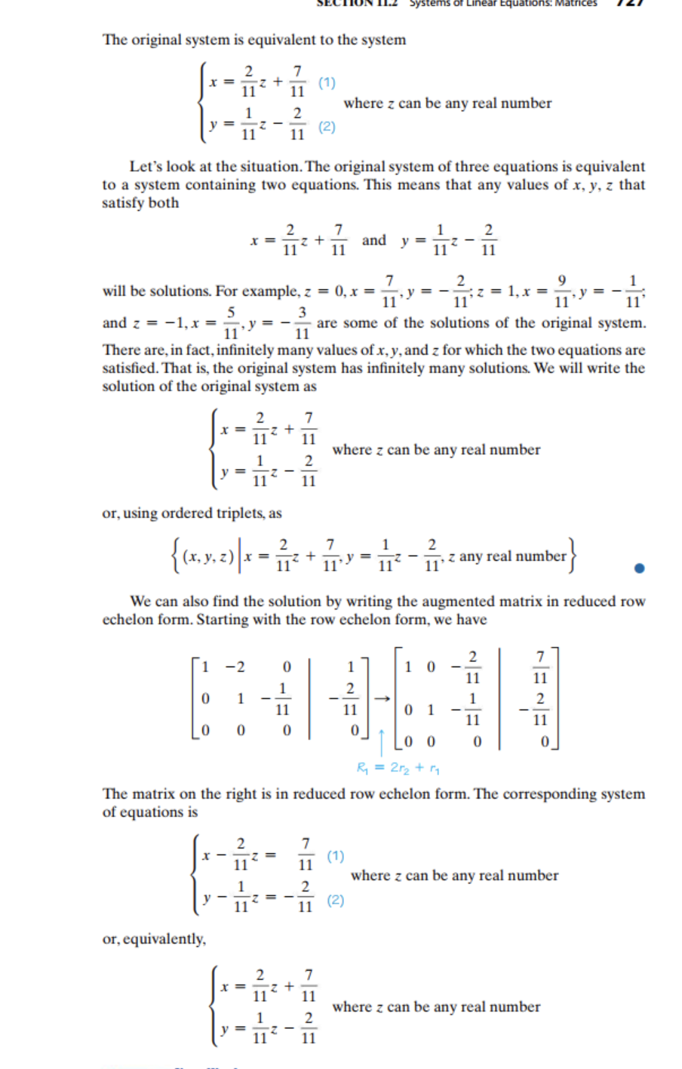

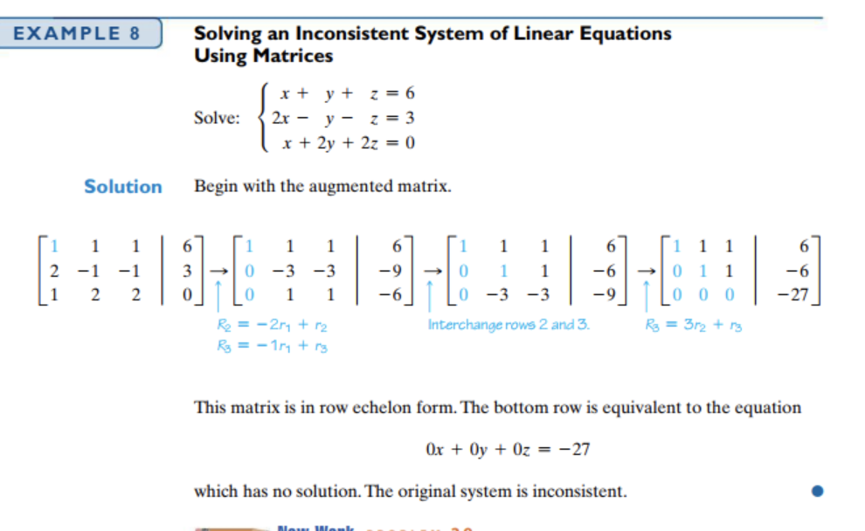

8.5i Determinants (not covering extensive properties as book does)

A determinant is a number corresponding to a square matrix, computed by following the processes described below. We can use determinants in a new method for solving linear systems called Cramer’s Rule which we will discuss later (8.5ii). Determinants have many properties and uses. You will learn more about determinants in Math 10.

2X2 Determinant:

If A =  then the determinant of A, denoted det(A) or |A| is computed as follows:

det(A) = ______________________ Examples:

General nxn determinants.

First some terminology:

The minor , , of entry  is defined to be the determinant of the matrix remaining when row i and

column j is deleted from matrix A.

The cofactor , , of entry  is defined to be  Note: this means that the cofactor is

either the same as, or the opposite of the minor, depending on whether  is even or odd.



A helpful tool for determining whether the sign of the cofactor is the same as or opposite to the sign of the minor. (that is, whether is positive or negative) is called the Array of Signs: 

Now, to find the determinant of matrix A, we expand across any row, or down any column by taking the sum of, the product of, each entry with its cofactor.







This method extends to any nxn matrix with the array of signs continuing in the checkerboard pattern.

Note: It is helpful to expand across a row/column with zeros.

 Ans: -494

8.5ii Cramer’s Rule for solving Linear Systems (adjoints not covered)

We can generate a formula for solving a system of equations by solving the general system:



So if D is the determinant of the coefficient matrix: D=

Dx is like D, but with x’s column replaced by the RHS. Dx=

Dy is like D, but with with y’s column replaced by the RHS. Dy=

Then  and  are the solutions to the equation ( D not equal zero). Cramer’s rule is particularly useful when the numbers are complicated.

Ex: 

This method extends to larger nxn linear systems.



8.4 Inverse Matrices (following text closely)

Much like ordinary algebraic equations, we may be asked to solve matrix equations.

Ex: If , , , solve the matrix equation 3A-2X=B for X

Ex: If , , , solve the matrix equation AX=B.

We seek a matrix such that . The matrix , if it exists, is called A inverse. (Note:  does not mean  here.

How do we find ? Consider the following example, which although not how we will actually find inverses, will give us an idea why the method we will learn works.

Ex to motivate inverse process (from text): Find the inverse if A=

Method for finding A-1 :

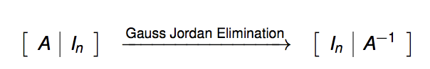

Using this method on the above matrix:

Using Matrix Equations and Matrix Inverses to solve linear systems.

Any linear system can be written in the form AX=B so if we could solve this type of equation, we can use this process as a new way of solving linear systems.

Ex: Now using the inverse above, we can finish the last example.

If , , , solve the matrix equation AX=B.

Notice, the above matrix equation is equivalent to the system:

Any system of linear equations can be written in the form AX=B and solved in this manner.

Ex: Solve by writing it as a matrix equations and solving the matrix equations

Example: Given , find 

Tip: You can check your answer *as you go* since  should equal 

EX: Solve 

Unit 1 part 2– Introduction to Angles

B1 Angles and Degree measure (read text pg 1390+)

Terminology: Initial side, terminal side, standard position, positive/negative direction, complementary, supplementary, right angle, quadrantal angle, coterminal, greek names, etc.

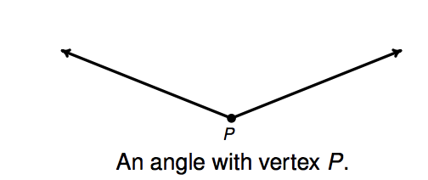 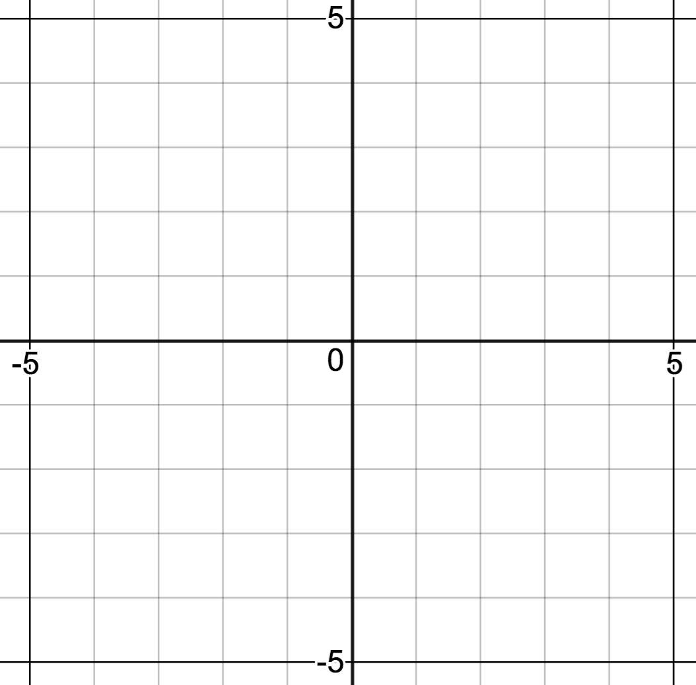

Degree Measure ______________________________

  

Quadrantal Angles 45 degrees 30, 60 degrees

(1/4 of revolution) (1/8 revolution) (1/12 , 2/12 of revolution)

Divide quadrant in half Divide quadrant in thirds

Locating Angles – Reference Angles

Make a rough sketch of each of the following angles in standard position. HOW did you decide where they were located?

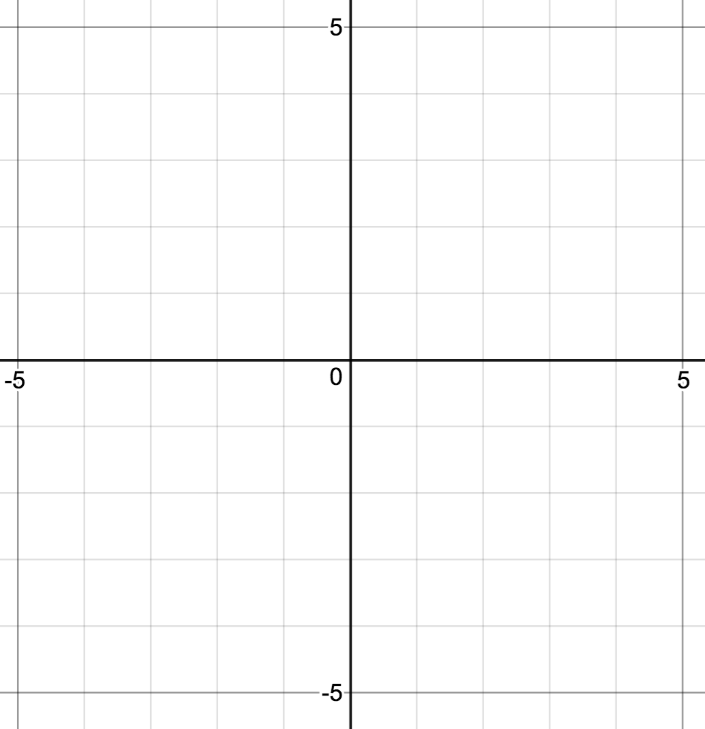     160o  250o 400o -178o - 260o

Reference angles can help us determine where an angle is located. A reference angle is the **acute** angle formed by the terminal side of a given angle, , and the nearest portion of the x-axis. Find the reference angles for each of the angles above.

Going “backwards”, sometimes we are given a reference angle and a quadrant corresponding to the terminal side of the angle and asked to locate the angle.

EX: Sketch an angle with reference angle of 10 degrees whose terminal side is in Quadrant 3. What is the measure of this angle? Give an angle coterminal with this angle. How many possible answers are there?



Other times the quadrant is not specified.

EX: Sketch terminal sides of all angles having reference angle of 30 degrees. How many such terminal sides are there? How many possible angles?



EX: Sketch terminal sides of all angles having reference angle of 83 degrees. How many such terminal sides are there? How many possible angles?



Converting Decimal Degrees  Degree-Minute-Second (DMS) : Read book pg 1392-1393.

1 degree = 60 minutes , 

1 minute = 60 seconds, 

Worksheet: Locating angles and REFERENCE ANGLES - degrees

(1) Make a rough sketch of each of the following angles in standard position and give the reference angle

  

170o 312o -102o

Reference Angle:

(2) For each of the following acute angles, find 4 angles, one in each quadrant, having the given angle as a reference angle.

|  |  |  |  |  |  |  |  |  |  |  |  |  |  |  |  |  |  |  |  |  |
| --- | --- | --- | --- | --- | --- | --- | --- | --- | --- | --- | --- | --- | --- | --- | --- | --- | --- | --- | --- | --- |
| |  |  |  |  |  | | --- | --- | --- | --- | --- | |  | Q1 | Q2 | Q3 | Q4 | | 20o |  |  |  |  | | 87o |  |  |  |  | | o(think!) |  |  |  |  | |

Worksheet:Getting Familiar with the Special Angles – Degrees

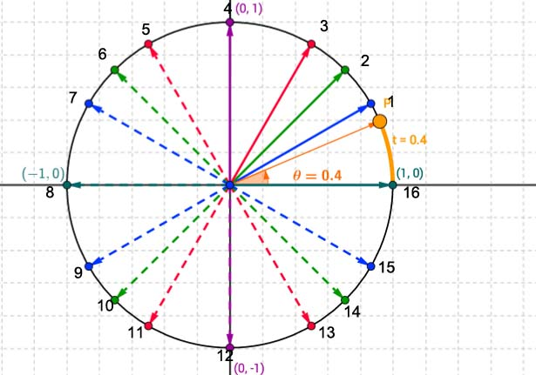

Given that all the “blue angles” have a reference angle of 30 degrees write the angle measure for each of the blue angles. (see link on math 8 page for color)

1) _______________________________ (note: the angle numbers are just for reference on this worksheet)

7)_______________________________

9) _______________________________

15)_______________________________

Given that all the “green angles” all have a reference angle of 45 degrees , write the angle measure for each of the green angles.

2) _______________________________

6)_____________135 degrees__________________

10) _______________________________

14)_______________________________

Given that all the “red angles” have a reference angle of 60 degrees write the angle measures for each of the red angles.

3) _______________________________

5)_______________________________

11) _______________________________

13)_______________________________

(worksheet continued next page)

(worksheet contd)

Locating Special Angles - Degrees

The “blue angles” all have a reference angle of 30 degrees .

The “green angles” all have a reference angle of 45 .

The “red angles” all have a reference angle of 60 degrees .

(ignore the orange here)



Locate the following angle and write the corresponding number for each of the following angles. (You need to get quick at this)

1__________6_______ 3 1

 _________________ 1____________________ 

1 _________________ ____________________ 

_________________ -2____________________  _________________

10.1i Angles and Radian Measure

Another way of measuring angles comes historically from measuring the length, s, of an arc subtended by an angle, q, whose vertex is at the center of the circle of radius r. (Central Angle).

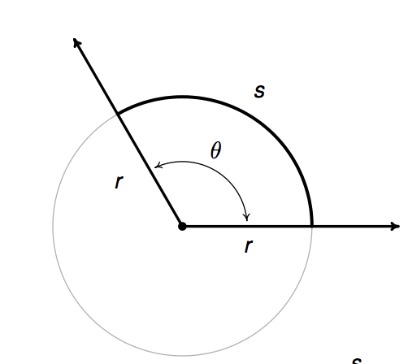

We know the circumference of the circle is C=2pr which leads to , that is the ratio of circumference to radius is a constant. In the same way, the ratio of arclength, s, to r is a constant. We call that constant q, and define q to be the radian measure. Thus  where q is in radians. Radians is a “dimensionless” unit. Another way that the idea of a radian is typically defined is that 1 radian is the measure of a central angle that subtends an arc whose length equals the length of the radius.

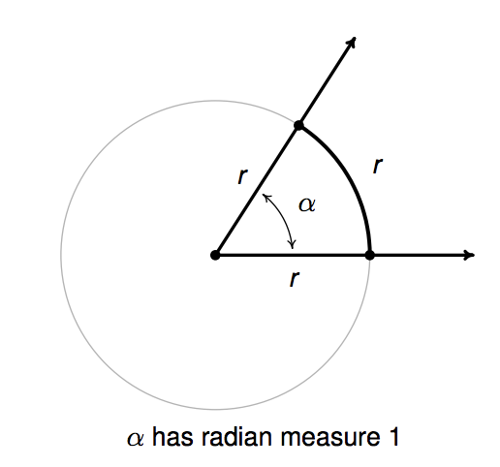 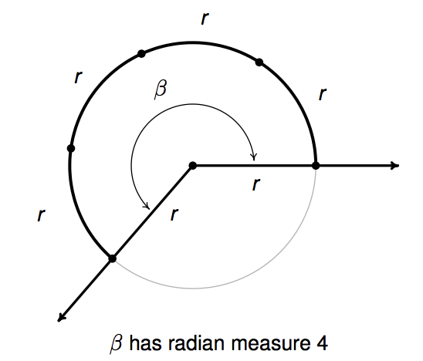

Using this definition, we can determine how many radians are in one revolution. _________________

Note: angle measure is not dependent on the size of the circle.

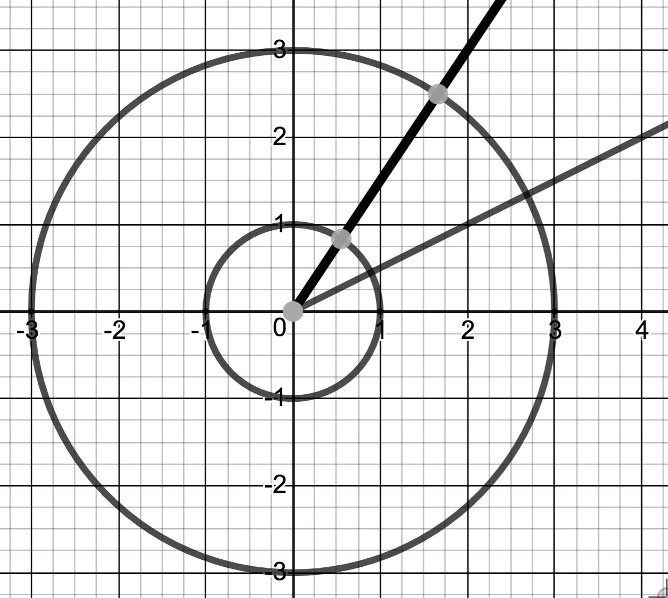

Now using the logic we did with degrees,

  

Quadrantal Angles _ ____________

(1/4 of revolution) (1/8 revolution) (1/12 , 2/12 of revolution)

Divide quadrant in half Divide quadrant in thirds

Locating angles in Radians – Same logic but more arithmetic

Locate  by comparing it to quadrantal angles to determine quadrant. Find and use reference angle. Also, find two angles coterminal with 

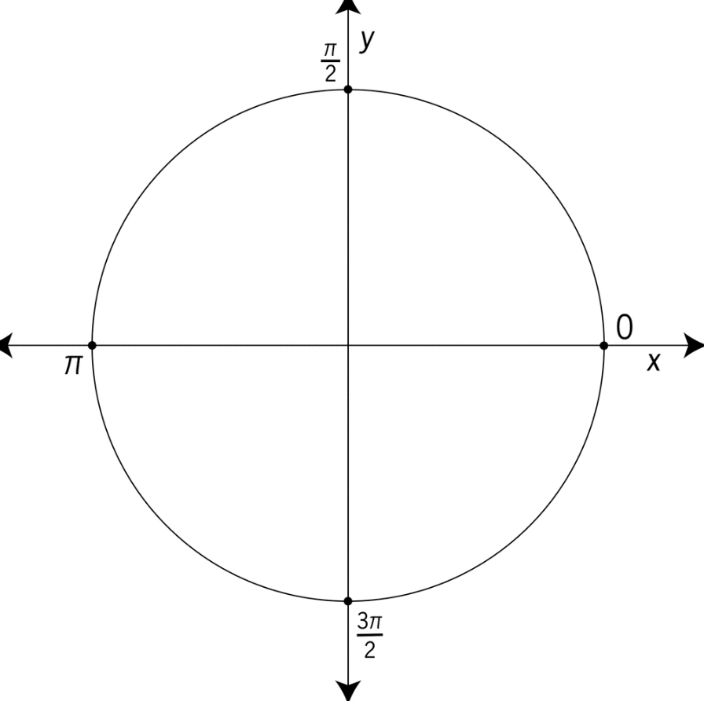

Locate each of the following angles(radians understood unless degrees specified) and find ref. angle.

   

   

EX: Sketch an angle with reference angle of  whose terminal side is in Quadrant 2. Note: How many possible answers are there? Give an angle coterminal with this angle.



Other times the quadrant is not specified.

EX: Sketch angles with reference angle of . How many such terminal sides are there? How many possible angles?



Converting Decimals Degrees: 1 revolution =, so conversion factor is 

1) Convert to radians

a)  b)  c)  d) 

2) Convert to degrees

a)  b)  c) 1

Important Advice: Practice radians so you are comfortable and can “think in radians”.

Worksheet: Locating angles and REFERENCE ANGLES - radians

(1) Make a rough sketch of each of the following angles in standard position and give the reference angle in radians

    p/10 3p/4 2p/3 6p/5

Reference Angle:

    3p/4 11p/8 23p/12 3

Reference Angle:

(2) For each of the following acute angles, find 4 angles, one in each quadrant, having the given angle as a reference angle. Answers should be given in radians

|  |  |  |  |  |  |  |  |  |  |  |  |  |  |  |  |  |  |  |  |  |  |  |  |  |  |  |  |  |  |  |
| --- | --- | --- | --- | --- | --- | --- | --- | --- | --- | --- | --- | --- | --- | --- | --- | --- | --- | --- | --- | --- | --- | --- | --- | --- | --- | --- | --- | --- | --- | --- |
| |  |  |  |  |  | | --- | --- | --- | --- | --- | |  | Q1 | Q2 | Q3 | Q4 | | p/7 |  |  |  |  | | p/8 |  |  |  |  | | p/12 |  |  |  |  | | 1 |  |  |  |  | |  radians |  |  |  |  | |

Worksheet: Getting Familiar with Special Angles - Radians



Given that all the “blue angles” have a reference angle of p/6 radians, write the angle measure for each of the blue angles.

1) _______________________________ (note: the angle numbers are just for reference on this worksheet)

7)_______________________________

9) _______________________________

15)_______________________________

Given that all the “green angles” all have a reference angle of p/4 radians, write the angle measure in radians for each of the green angles.

2) _______________________________

6)_______________________________

10) _______________________________

14)_______________________________

Given that all the “red angles” have a reference angle of p/3 radians, write the angle measure in radians for each of the red angles.

3) _______________________________

5)_______________________________

11) _______________________________

13)_______________________________

(worksheet cont’d next page)

(worksheet cont’d )

Worksheet: Locating Special Angles Worksheet 2 radians Name: ______________________

The “blue angles” all have a reference angle of p/6 radians. (see website for colors)

The “green angles” all have a reference angle of p/4 radians. .

The “red angles” all have a reference angle of p/3 radians.

(ignore the orange here)



Locate the following angle and write the corresponding number for each of the following angles. (You need to get quick at this)

p/6 _________________ 5p/6  5p/3 

3p/4 _________________ 4p/3 ____________________ 3p 

p/2 _________________ -7p/6 ____________________ -p/2 

p/4 _________________ -2p/3 ____________________ 1p/6 _________________

Worksheet -Special Angles Handout – Mixed



Given that all the “blue angles” have a reference angle of 30 degrees or p/6 radians, write the angle measures, both in radians AND degrees, for each of the blue angles.

1) _______________________________ (note: the angle numbers are just for reference on this worksheet)

7)_______________________________

9) _______________________________

15)_______________________________

Given that all the “green angles” all have a reference angle of 45 degrees or p/4 radians, write the angle measures, both in radians AND degrees, for each of the green angles.

2) _______________________________

6)_______________________________

10) _______________________________

14)_______________________________

Given that all the “red angles” have a reference angle of 60 degrees or p/3 radians, write the angle measures, both in radians AND degrees, for each of the red angles.

3) _______________________________

5)_______________________________

11) _______________________________

13)_______________________________

(worksheet cont’d next page)

(worksheet cont’d)

Special Angles Worksheet -Mixed

The “blue angles” all have a reference angle of 30 degrees or p/6 radians.

The “green angles” all have a reference angle of 45 degrees or p/4 radians.

The “red angles” all have a reference angle of 60 degrees or p/3 radians.

(ignore the orange here)



Write the corresponding number for each of the following angles. (You need to get quick at this)

p/3 _________________ 7p/6____________________ 1

7p/4 _________________ 2____________________ 5p/6

5p/3 _________________ -p/4____________________ 3

- _________________ p/2 ____________________ 5p/2

1p/4 _________________ -7p/6____________________ 

-1_________________ 4p/3____________________ 3

p/3 _________________ 7p/6____________________ 1

18 _________________ 5p/4 ____________________ 1p

1 _________________ 4p ____________________ p/4

Symmetry and Important Points on the Unit Circle.

We are often interested in looking where the terminal side of some of the “key angles” mentioned earlier intersect the “unit circle”  .Notice the symmetry that angles with the same reference angle have (blue->p/6, green->p/4, red->p/3). Suppose the points in the first quadrant were given. Can you fill in the rest?

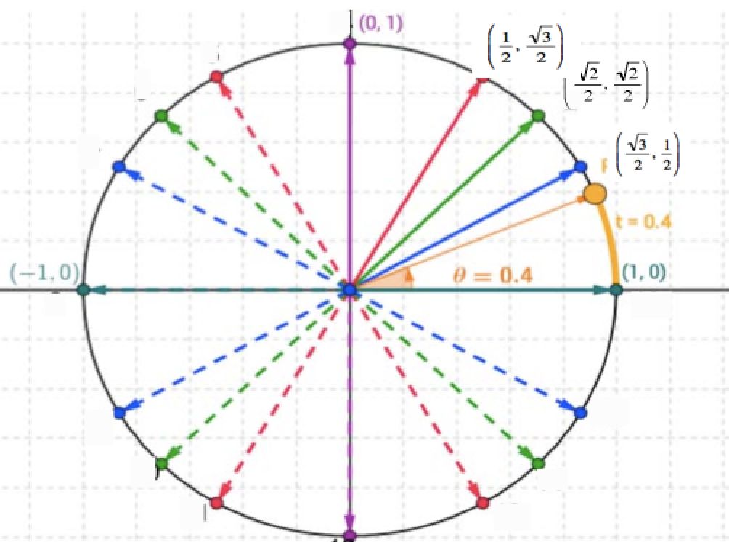

Alternate helpful graphic. <http://www.pccmathuyekawa.com/classes-taught/math_7ab/worksheets/unit%20circle012.pdf> *(see math 8 page – unit circle graphic)*

Animation: <https://www.desmos.com/calculator/evltrytg3v> *(see math 8 page – demos anim. w/triangle)*

Practice knowing all these locations and points <https://www.purposegames.com/game/b58f83e30d> *(see math 8 page – unit circle practice)*

Example:

Find the point on the unit circle corresponding to  ___________________

Find the point on the unit circle corresponding to  ___________________

Find the point on the unit circle corresponding to  ___________________

Find the x coordinate of the point on the unit circle corresponding to  ___________________

Find the y coordinate of the point on the unit circle corresponding to  ___________________

How do we find those points in the first quadrant if they are not given?

Worksheet: Finding points on unit circle for key angles.

Find the points on the unit circle corresponding to each of the following angles



The “blue angles” all have a reference angle of 30 degrees or p/6 radians. The “green angles” all have a reference angle of 45 degrees or p/4 radians. The “red angles” all have a reference angle of 60 degrees or p/3 radians.

You will need to be able to do this without the picture above so see what you can do without the picture,

p/3 _________________ 7p/6____________________ 1

7p/4 _________________ 2____________________ 5p/6

5p/3 _________________ -p/4____________________ 3

- _________________ p/2 ____________________ 5p/2

1p/4 _________________ -7p/6____________________ 

-1_________________ 4p/3____________________ 3

p/3 _________________ 7p/6____________________ 1

18 _________________ 5p/4 ____________________ 1p

1 _________________ 4p ____________________ p/4

SAMPLE TEST

NOTE: Sample tests are not meant to be a complete study guide. This is just a test that was given on this material one time. Yours will be similar in length and difficulty but will not be exactly the same. There may be topics from the homework that are not covered on this test but WILL be on your test. Working these problems, without referring to notes or solutions should be only ONE PART of your study.

* Notebook should be turned in before test. It will not be accepted after.
* Phones must be turned OFF and put away. Any visible phone (smart watch, headphones, ipad etc.) will result in a grade F .
* No scratch paper or notes.
* No graphing calculator.
* No credit will be given for solutions if work is not shown.
* I expect clear and legible presentations .

(1) Same figure as on homework, see board for colors.

The “blue angles” all have a reference angle of 30 degrees or p/6 radians.

The “green angles” all have a reference angle of 45 degrees or p/4 radians.

The “red angles” all have a reference angle of 60 degrees or p/3 radians.

(ignore the orange here) (12 points)



Write the corresponding number for each of the following angles:

15_________________ 7p/6____________________ 

7p/4 _________________ _________________ 11p/6

4p/3 _________________ 3p/2____________________ **-**p/3

-3_________________ p/3 _________________ 5p 

What are the coordinates of the points at: 3 points

1) 7)

2) 11)

3) 14)

(2) Solve using any of the methods discussed in class. (10 points)



(3) Use Cramer's Rule to solve the following system.  (8 points)

(No credit given for a different method)

(4) Given the following matrices: ( a-d, 2 points each; e,f 4 points each)



Find the following, if possible. (If not possible, say so.)

(a) A + C (b) AC

(c) BC (d) det(C)

(e) AD (f) det (B)

(5) Given 

(a) Find A-1 (10 points)

(b) Solve the system of equations by writing it as a matrix equation Ax=B and using the inverse of the coefficient matrix (which you found in part a).  (3 points)

(6) (a) Convert from DMS (degree, minute seconds)to decimal degrees, show work. 

(8 points)

(b) Convert from decimal degrees to DMS , show work. 

(c) Convert from radians to degrees: 

(d) Convert from degrees to radians, exactly (no calculator): 

(7) Graph the angle  in standard position. Give two coterminal angles, one of which is positive and the other negative. Find the reference angle. (8 points)

Coterminal positve _______ Coterminal negative ________ Ref angle_____

(8) (For each of the following acute angles, find 4 angles, one in each quadrant, having the given angle as a reference angle. Answer in the units given, exactly. (12 points)

|  |  |  |  |  |  |  |  |  |  |  |  |  |  |  |  |  |  |  |  |  |
| --- | --- | --- | --- | --- | --- | --- | --- | --- | --- | --- | --- | --- | --- | --- | --- | --- | --- | --- | --- | --- |
| |  |  |  |  |  | | --- | --- | --- | --- | --- | |  | Q1 | Q2 | Q3 | Q4 | | 23o |  |  |  |  | | p/5 |  |  |  |  | | 02 |  |  |  |  | |

(7) Use matrix methods (Gaussian elimination or Gauss Jordan) to solve: (10 points)



**You must obtain row echelon form or reduced row echelon form. Be sure to label operations performed at each step.**